Reid, Tammie (largely based on “Echoes from the forest”, editor Roger Underwood (1990))
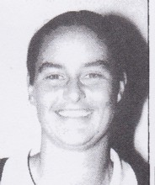
Graduated in c1980 with BSc Forestry from ANU. She was the first female professional forester to be employed in a District office by the Forest Department. Started work at Busselton in 1981. Assisted with the development of pine plantations in the sunklands. Interpretation and Education Officer in 1989.

